**Cloud based Smart health care system**

**Khushi**

**KIET Group of Institutions, Delhi-NCR, Ghaziabad, India**

[**khushi.2024cs1208@kiet.edu**](mailto:khushi.2024cs1208@kiet.edu)

**Chhayank Tyagi**

**KIET Group of Institutions, Delhi-NCR, Ghaziabad, India**

[**chhayank.2024cs1010@kiet.edu**](mailto:chhayank.2024cs1010@kiet.edu)

**Hanu Agarwal**

**KIET Group of Institutions, Delhi-NCR, Ghaziabad, India**

[**hanu.2024cs1020@kiet.edu**](mailto:hanu.2024cs1020@kiet.edu)

**Harsh Khatter**

**KIET Group of Institutions, Delhi-NCR, Ghaziabad, India**

[harsh.khatter@kiet.edu](mailto:harsh.khatter@kiet.edu)

**Abstract:**

1. **INTRODUCTION**

The main objective of the work is to accurately store the reports and records of patients such as lifestyle habits, and medical history. This paper includes a solution which will help in selecting the doctors for the disease based on the given symptoms by the user and his/her reports. Various other components are studies which derives the motive of the proposed system, which is to provide one stop solution for many facilities and enhance existing health care systems by giving the feature of generic medicines.

The proposed system helps in buying medicine at low cost by comparing cost of medicine on all the online pharmacy and it will help a lot to the patients. This is hyperlink to the modules. The doctor module of the work inferences:

* Doctors can easily view their all the patients either present or past.
* Doctors are also free to take help from the prescription of others doctors.

1. **LITERATURE SURVEY**

**Various papers and the systems are studied to infer the**

**Research Paper 1 –**

**Smart Care: An Introduction**

Smart Care is a project aimed at creating a smart environment for aging in place, based on a retirement community apartment. The system uses unobtrusive sensing technologies to enable non-intrusive at-home monitoring, diagnostic support, and self-management in complex treatment plans. The prototype has been deployed in an independent living apartment at Lakewood Village Senior Living Community, allowing testing and evaluation of the technologies in a real elder care environment. The SmartCare project consists of three main data layers: data layer, analysis layer, and interface layer. The visualization module(VISMA) allows for real-time visualization of the current state of the apartment or re-visualization of the past data for later analysis. The SmartFloor is a pressure-sensitive floor designed to balance parameters, built on disc-like sensors deployed in a one-foot side-length square matrix configuration. Smart Care apartment features are also implemented with a small curtains system along with some smart appliances.

**Research Paper 2 –**

**Designing Interactive Health Care Systems: Bridging the Gap Between Patients and Health Care Professionals**

This research paper give knowledge about the patient-healthcare professional relationship is evolving as patients become more proactive about their health and turn to technologies like the Internet for knowledge acquisition. This study examines the high-level design of a perceived medical system and the implications of adding patients as active contributors. The main challenge of modifying existing systems to incorporate patient interaction is preserving system integrity. A systematic approach is proposed to support scaling health care systems while preserving system integrity. Distributed systems like personal health records and eHealth systems provide two ways for patients to become more involved with their own health care. One is the lack central control in distributed systems which adds complexity to health systems, posing challenges for design and modification. Secondly the use of the emergent behaviour detection (EBD) tool which offers potential cost savings by proactively identifying behaviours during the design phase. The study concludes that creating a distributed system to support patient’s health information is challenging, and future work should include integrating emergent behaviour detected into the software design, expanding the clinical workflow, and using the EDB software to detect emergent behaviour in more mature design.

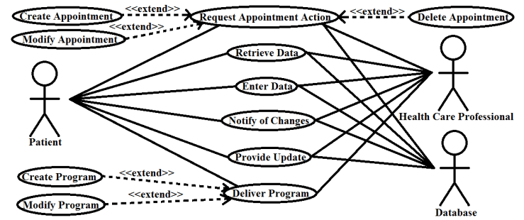

**Figure : Use case diagram of proposed modified system. Here, the patient has more points of entry into the system. The health care professional and patient work together to contribute to the patient's information.**

**Research Paper 3 –**

**Software Engineering in Health Care**

Software Engineering is a vital field in healthcare aimed at improving patient care and reducing costs. However, challenges include subjective patient and care provider, localized practices and a knowledge to handle the complex data. Healthcare software must be heavily customized to fit individual settings along with verification and validation of the software with the help of enginnering. In conclusion, finding sustainable access to quality healthcare in the face of aging populations and increasing treatment costs is a significant challenge for countries worldwide. Software systems have the potential to be a key enabling technology in addressing this challenge.

**Research Paper 4 –**

**Smart healthcare: making medical care more intelligent**

This research paper give knowledge about the Smart healthcare, born from IBM's "Smart Planet" concept in 2009, is a revolutionary approach to healthcare using IoT, mobile internet, cloud computing, big data, 5G, AI, and biotechnology. It aims to improve individualized healthcare and efficiency in the medical field. Key components include wearables, remote monitoring, telemedicine, and self-service healthcare. Technologies like AI, surgical robots, and mixed reality have transformed disease diagnosis and treatment. Smart healthcare emphasizes patient empowerment, real-time monitoring, and cost reduction through IoT-connected devices and smart homes. Wearables, apps, and virtual assistants enhance disease prevention and personalized care. Smart hospitals improve patient and staff experiences. Integrating big data and AI streamlines drug development, but challenges like standardized regulations and data integrity remain. Collaboration is key to realizing smart healthcare's potential.

**Research Paper 5 –**

**A REVIEW PAPER ON SMART HEALTH CARE SYSTEM USING INTERNET OF THINGS**

The document introduces the concept of Smart Health, which utilizes IoT technology to address global healthcare challenges. It emphasizes issues such as child mortality, sanitation, and prevalent diseases, highlighting the role of IoT in connecting devices and its applications in healthcare and smart environments. Smart Health integrates IoT into healthcare by using biometric sensors for real-time health monitoring, with a focus on improving efficiency and cost-effectiveness. The document outlines a remote health monitoring system that includes sensor data acquisition, cloud-based data storage, and an Android app for real-time access and communication between patients and healthcare providers. In summary, Smart Health leverages IOT to tackle healthcare challenges, with an emphasis on real-time monitoring and communication improvements to address global health concerns.

**Research Paper 6 –**

**The roles of trust, personalization, loss of privacy, and anthropomorphism in public acceptance of smart healthcare services**

This research paper delves into trust and unique three AI traits' significance(i.e. personalization , loss of privacy , anthropomorphism) in people accepting smart healthcare services using Technology acceptance Model. It reveals that people's belief in usefulness, ease of use, and specific AI features hugely affect their acceptance. Trust, usefulness, and customization directly shape people's intention to use these services. Data collected from 769 samples using partial least square equation modelling technique.The aim of paper was to validate a theory to examine acceptance behavior of Smart HealthCare Services. The Proposed model was tested using consumer data of SOJUMP company, the result of study explained 66.4% of variance in behavioral intention of Smart Healthcare services.

Additionally, this study shows that trust, usefulness, and customization vary depending on gender, age, and experience. The average age of participants was 30.12 years, with a standard deviation of 6.80. Out of 769 participants, 335 (43.56%) were male, and 434 (56.44%) were female. A significant majority (73.34%) of participants had knowledge of smart healthcare services, while fewer than half (46.16%) had prior experience using these services.Finally study shows Trust is the key in shaping user..

**Research Paper 7 –**

**The affective atmosphere of rural life and digital healthcare: Understanding older persons’ engagement in eHealth services**

This article delves into the emotional dimensions of implementing eHealth for elderly individuals in rural areas, focusing on the affective atmospheres. This paper explores how emotions influence the involvement of elderly individuals in rural eHealth, particularly in the context of digital healthcare technologies in Northern Sweden's inland regions. It employs the concept of "affective atmospheres" to examine the emotional connections and power dynamics associated with specific places. The article uses interviews and Findings reveal that participants' emotions such as resignation, necessity, reduced entitlement, and defiance significantly shape their perceptions of eHealth solutions. This affective atmosphere illustrates the interaction between human subjects and digital elements, with shared imagery related to geographic space and age playing pivotal roles.

Digital healthcare technologies have arisen as symbols of rural decline and urbanization, often seen as "second-best solutions" when local welfare services are reduced. The participants in this study had conflicting emotions about these technologies, but surprisingly, their involvement in local eHealth initiatives was influenced by context-specific compromises, including shared sentiments related to location-based and age-related circumstances and perceptions.

**Research Paper 8 –**

**Smart healthcare support for remote patient monitoring during covid-19 quarantine**

Amid the COVID-19 pandemic, healthcare practices have shifted, discouraging frequent hospital visits. However, some patients still require ongoing monitoring for their well-being. To address this, a remote smart home healthcare support system (ShHeS) is proposed. It enables the remote monitoring of patients' health and the receipt of prescriptions. This system employs an Android-based mobile app and a web-based platform for efficient communication. Sensors automatically gather vital health data, and a hyperspace analogue to context (HAC) enhances system performance. ShHeS allows patients in self-isolation or quarantine to send daily health updates to doctors, promoting better health and a comfortable lifestyle. The main aim of the system is to assist out-patients and patients in prescribed isolation to live a comfortable life at home which is controlled using SmartPhone and reduce the stress of visiting hospitals often before consultation with their doctors.

**Modules**

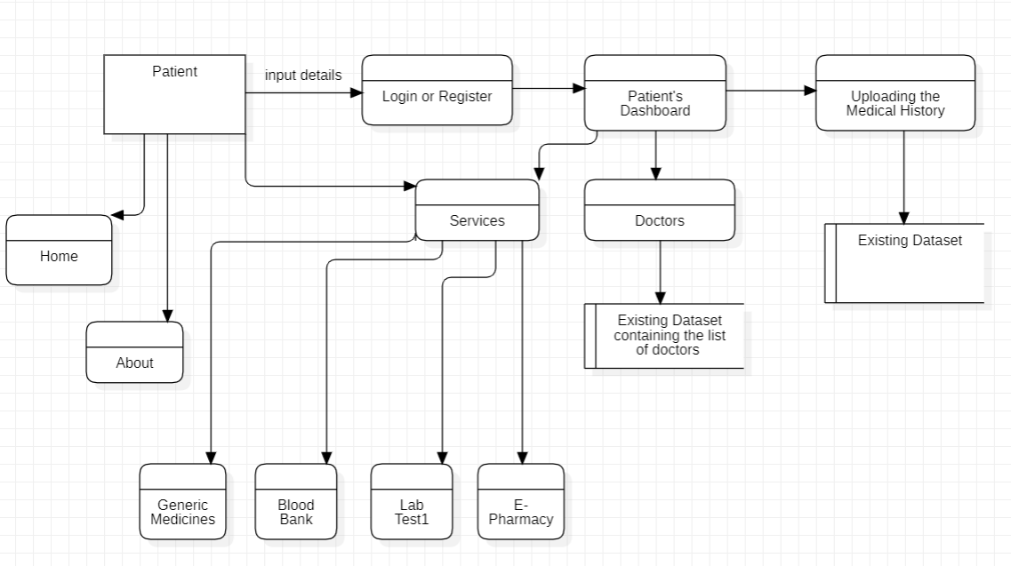

**Figure : Showing the patient’s data flow diagram level 1**

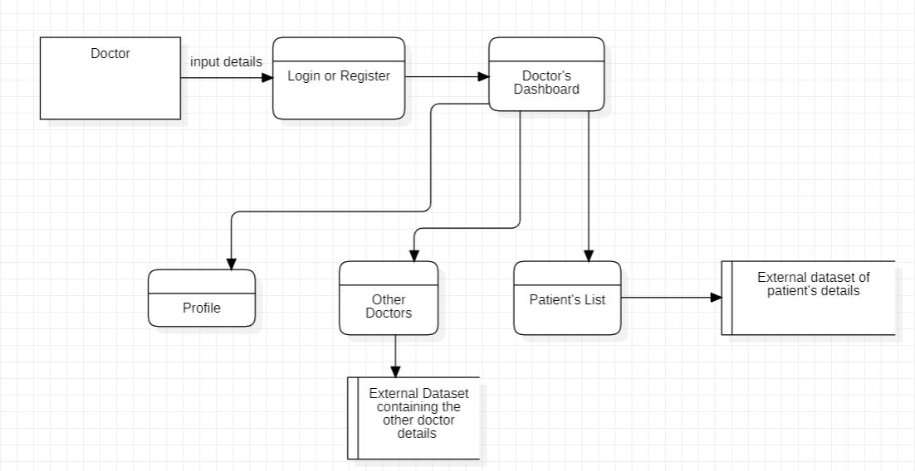

**Figure : Showing the Doctor’s dataflow diagram level 1**

**Service Page –**

* This is most important modules including many government services and generic services.
* Blood Bank is very necessary now days and this module include access links of government blood bank websites and listing necessary details regarding them.
* E pharmacy is pharmacy where we can buy medicines online and delivered at our doorstep at lowest price and with assured company.
* Path Labs is nearest path labs your location with price tags of many important medicals test and report at your doorstep.

**Doctor-**

* This is the main module including many features:-
* Profile page include doctor experience and history of previous hospitals and many more.
* Patient record includes all the patients of doctor with medical history all reports , medicines and diseases .
* Doctors includes other doctors that are registered and every doctor can see other doctor profile for their patients and for their knowledge.

**Patient-**

* This module is for patients :-
* Profile page include patients profile of previous doctor visits and medical reports .
* All doctors where visit for chech up and prescription given by doctor.
* Patient can view all their past documents in digital format.

**Technology**

* **Hardware –**

Even though this architecture is hardware- software integrated web architecture, we will not be designing any specific hardware interfaces to run the system. Our system is a web-based system, so we will be launching it in several computers online. Smart care projects may integrate with EHR systems to provide healthcare professionals with access to patient data. These systems can be connected to the web-based platform via APIs.

* **Software –**

The Smart Care WebApp will depend on several open-source software components, including Html, CSS, JavaScript, API’s ,Spring MVC, Spring Security, Spring JDBC and Spring Boot. These components will be integrated into the web application to provide the necessary functionality and user interface. It is important to note that the operating environment described above is subject to change based on the needs of the project and the evolving requirements of the web application. It is recommended that the development team regularly review and update the operating environment to ensure that the software remains compatible with the latest technologies and platforms.

**Implementation**

**Difficulty for patients in changing their doctor**-

* As their are lot of cases in which patients wish to change their doctors due to any reason whether the treatment is not suiting to his/her health, distance apart and many more.
* So in this case patients are unable to tell all their past history treatment clearly.
* This system is used to store each and every document of the particular patient.

**e- pharmacy –**

* E-Pharmacy can be a built in feature of this project
* By using online pharmacy the user can order the medicine anytime and anywhere.

**PAth Labs –**

It encorporate the pathology labs, it will save a lot of time and allows the user to access all the options on a single website rather than searching each website individually.

**Doctor’ Dashboard –**

Doctor’s Dashboard allows doctor’s to access the appointed patient’s only. Doctor can see their past records also such as medical records, test results and past prescriptions (from other doctor). As doctor has to provide the electronic prescriptions, which reduces the risk of errors and making it easier for patients to refill their prescriptions. It also consists of many other options such as other doctors where the list of registered doctors are made visible.

**END USERS**

**Patients –**

* Can save their documents
* Check for doctor according to their needs
* Compare medicine price

**Doctors-**

* Can save their patients history
* Take Help prescription of other doctors

**ADVANTAGES**

* Access **-**the access of our website is not restricted to registered users only. Someone who is not registered can also visit the website
* User Registration and login **-** A user, must be able to register their credentials. one should provide their basic information eg. Name, address, email, phone number to create the profile.
* Electronic Health Records **-** This is a feature to digitalize the patient’s medical records , It’ll contain the patient's medical history, diagnoses, medications, treatment plans, immunization dates, and laboratory test results.
* Telemedicine **-** This feature allows the patient to buy the medicine online form the registered government websites. This feature helps the user to buy the medicines in low prices as compared to all other private medicines shop.
* Online Blood bank **-** This features allows the patient to see the blood donors availability according to the blood group. This is also the registered and approved government website which will provide the filtered data so that the relevant information of the acceptor and donor is displayed.
* Online Path Labs **-** This feature allows the patient to access the government official website for appointing the test in pathology labs. This is also the home service provided by the government to the patients.

**Results**

The Smart Healthcare website which aims to solve many problem of patients and doctors that it provides the facility of saving the medical reports online. Sometimes when patients changes their doctors, then some of patients lost their prescriptions and are unable to tell doctors about their previous health issues so they can save all of their reports and documents on the platform for their better cure and this help a lot to patients as well as doctors. The platform is also helpful for doctor as they can save all their patients history in efficient manner. Doctors can also refer prescriptions of other doctor for betterment , both patients and doctor can also compare price of medicine so that they can save their money.

**References**

<https://crystal.uta.edu/~burns/pdfs/SmartCare%20-%20An%20Introduction.pdf>

<https://doi.org/10.1016/j.chb.2021.107026>

<https://ieeexplore.ieee.org/document/6602469>

<https://ieeexplore.ieee.org/document/6864347>

<https://crystal.uta.edu/~burns/pdfs/SmartCare%20-%20An%20Introduction.pdf>